NAME: KELETSO JOY DITLHOTLHOLE
STUDENT ID: 202002023
CSI223

- Getting started with MySQL accounts:
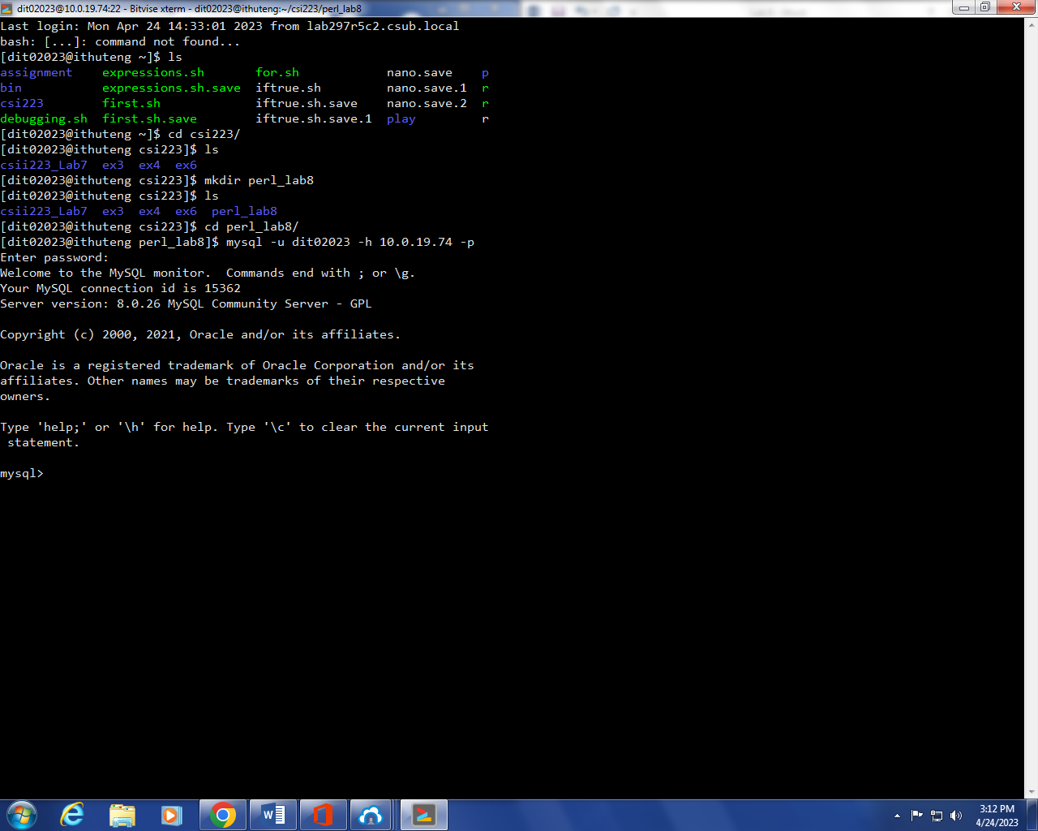

- Copied the clients.txt file into the folder
-Then I created the database
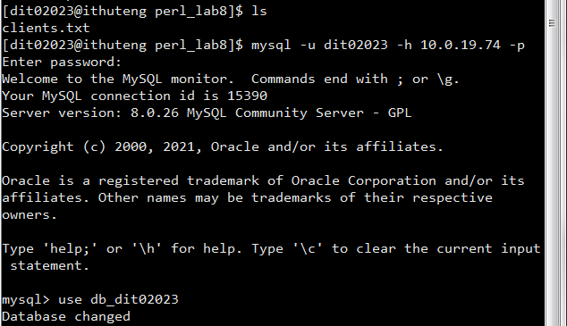

-Then I created the table by writing the query
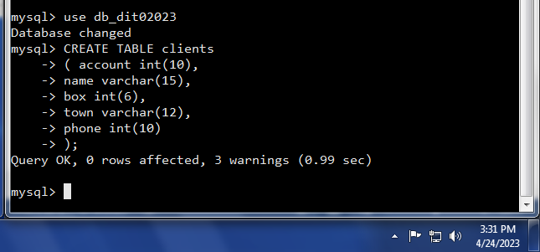

-Checking if the tables have actually been created:
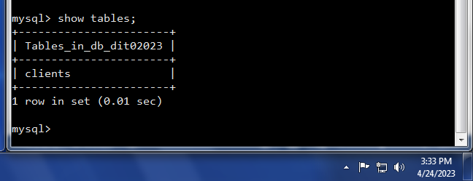

-Displaying the contents of the currently empty table.
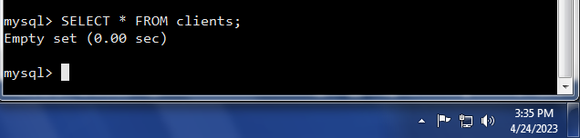

- PERL AND MySQL


